 | 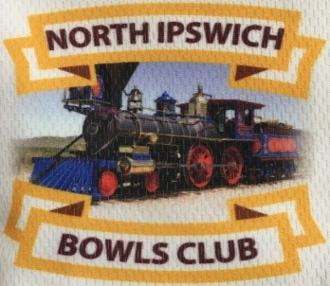 | 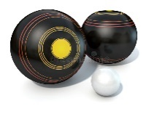

OPEN 3 BOWL PAIRS
SPONSORED BY ~ Kent Rohl ~ eXp Real Estate
SILVER SPONSOR ~ Jets Leagues Club
SUNDAY 14 APRIL 2024

PRIZE MONEY $1180
NOMINATION $40 per team
NOMINATIONS to be emailed or texted to ~~

Vicki Cameron Ph: 0438 264 339 OR Denise Doyle Ph: 0415 549 888

Club Email: northipswich@bigpond.com

Nominations close 5 pm Sunday 7 April.

(( Dietary requirements to be advised with Entry OR prior to closing date - 7 April. ))

PRIZES TO 7TH PLACE + ROUND WINNERS
Morning Tea 8.15 am  First Game ~ 9.00 am – 11 am  15 minute break  Second Game ~ 11.15 am – 1.15 pm  LUNCH  Third Game ~ 2.00 pm – 4.00 pm  Presentations | CONDITIONS OF PLAY  No Dead Ends >> ( Respot on T )  2 Points for a win plus Margins >>  WINS take Precedence  3 GAMES OF 13 ENDS  (( OR 2 HOURS ))  Each team is eligible to win one (1) prize only.

The Competition will be held under the control of the NIBC Match Committee and the Laws of the Sport of Bowls (Crystal Mark 4th Edition Apr 2023).

